Sajeevan Arunthavaratnam 202220321

Python Assignment

1. Leap Year

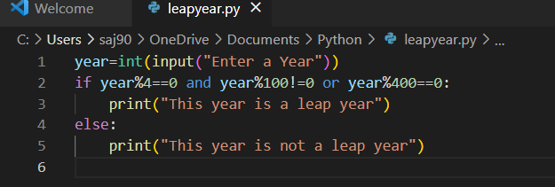

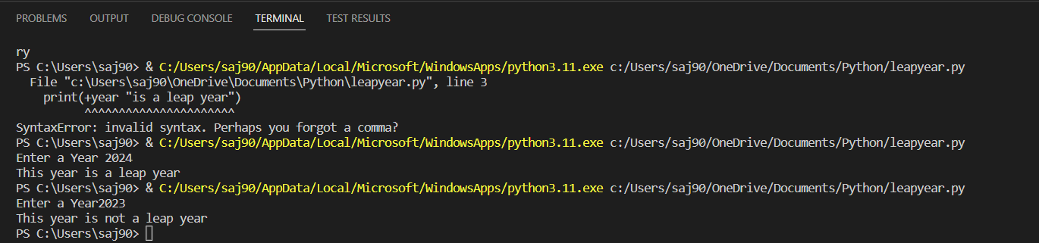

The year needs to be divisible by 4 or 400 to be leap year and cannot be divisible by 100 therefore I used the ‘and’ & ‘or’ statements

1. FizzBuzz

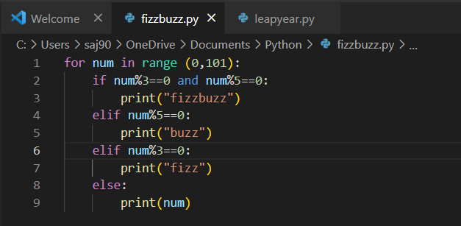

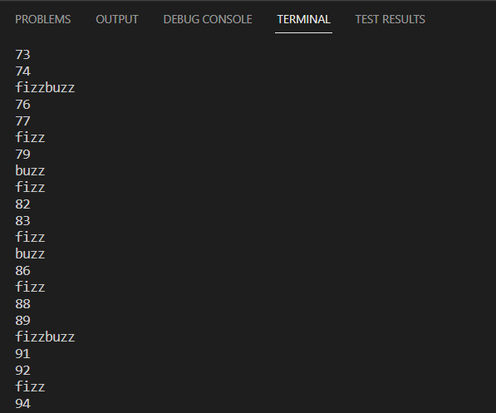

To be multiples of 3s and 5s we must be able to divide the numbers by those numbers. So I ranged the numbers and used if, elif and else to print out when a number will be fizz or buzz or fizzbuzz

1. Reversed string

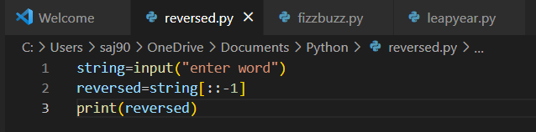



The command ::-1 will reverse your string and the higher the number you put example ::-2 it will skip every letter of each word